**Assignment -1**

Python Programming

|  |  |
| --- | --- |
| Assignment Date | 16 September 2022 |
| Student Name | Ms M.Kaviya sree |
| Student Roll Number | 113219071014 |
| Maximum Marks | 2 Marks |

**Question-1:**

**Split this string**

|  |
| --- |
| **Solution:** |
| s = "Hi there Sam!"  a=s.split()  print (a) |

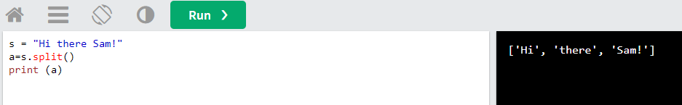

**Question-2:**

## Use .format() to print the following string.

### **Output should be: The diameter of Earth is 12742 kilometers**.

|  |
| --- |
| **Solution:** |
| planet **=** "Earth"  diameter **=** 12742  print("The diameter of {} is {} kilometers."**.**format(planet,diameter)) |

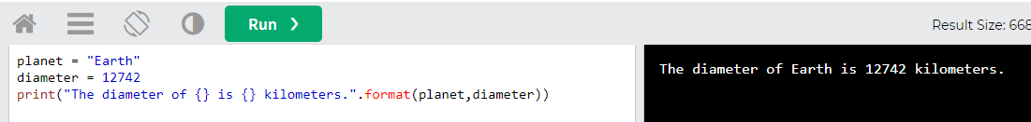

**Question-3:**

## In this nest dictionary grab the word "hello"

**Solution:**

d**=**{'k1':[1,2,3,{'tricky':['oh','man','inception',{'target':[1,2,3,'hello']}]}]}

a=d['k1'][3]['tricky'][3]['target'][3]

print(a)

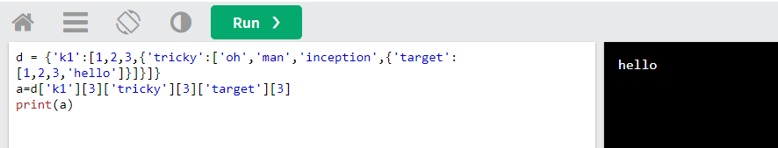

**Question-4:**

**NUMPY**

## 4.1-  Create an array of 10 zeros?

**Solution:**

## import numpy as np

## a=np.zeros(10)

## print(a)

## 

## 4.2 Create an array of 10 fives?

**Solution:**

## import numpy as np

## a=np.ones(10)*5

## print(a)

## 

## 5. Create an array of all the even integers from 20 to 35

**Solution:**

import numpy as np

a=np.arange(20,35,2)

print(a)

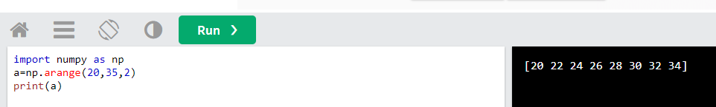

## 6. Create a 3x3 matrix with values ranging from 0 to 8

**Solution:**

import numpy as np

a=np.arange(0,9).reshape(3,3)

print(a)

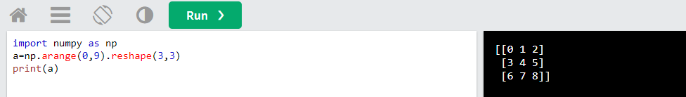

## 7. Concatenate a and b

## a = np.array([1, 2, 3]), b = np.array([4, 5, 6])

**Solution:**

## import numpy as np

## a = np.array([1, 2, 3])

## b = np.array([4, 5, 6])

## c=np.concatenate((a,b))

## print(c)

## 

# **Pandas**

## 8. Create a dataframe with 3 rows and 2 columns

**Solution:**

import pandas as pd

a = {'col': [6,7,9],'col_1': [2,3,0]}

df=pd.DataFrame(a)

print(df)

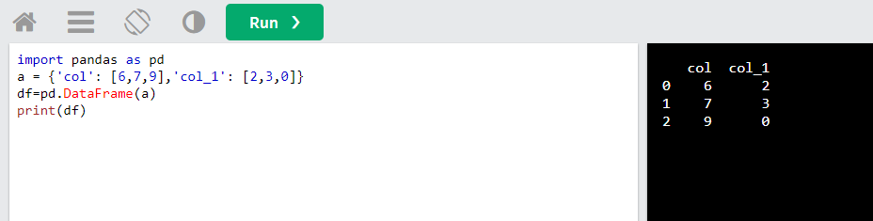

## 9. Generate the series of dates from 1st Jan, 2023 to 10th Feb, 2023

**Solution:**

## import pandas as pd

## date=pd.date_range(start='01-01-2023',end='10-02-2023')

## print(date)

## 

## 10. Create 2D list to DataFrame

**lists = [[1, 'aaa', 22], [2, 'bbb', 25], [3, 'ccc', 24]]**

**Solution:**

import pandas as pd

lists = [[1, 'aaa', 22], [2, 'bbb', 25], [3, 'ccc', 24]]

df=pd.DataFrame(lists)

print(df)

